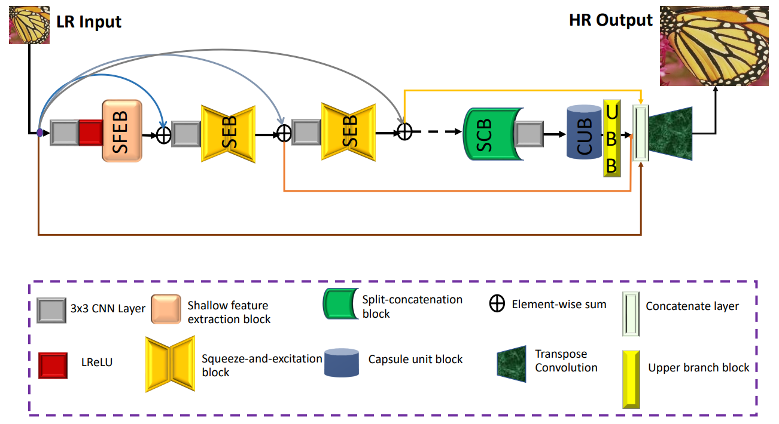

The proposed framework of Squeeze-and-ExcitationNext for Single Image Super-Resolution (SENext)